Online Store

Overview

Contents
Messaging 2
Quick Pitch 2
Top-line Benefits 2
Supporting Statistics 2
Detailed Benefits 2
Features 4
Features Overview 4
Supported Gateways/Payment Processors 5
Customer Experience 7
Sales Support 14
Probing Questions 14
Selling Points 14
Objection Handlers 15
Frequently Asked Questions 17
General 17
Management & Installation 20
Plans & Pricing 20
Payment Integrations 21
Shipping 21
Full Feature List 22

Messaging

Quick Pitch
Start selling online in no time with Online Store.
Have your customers build their business by selling products on their website with Online Store. Integrated directly within the Online Presence Builder, Online Store makes it simple to add products for sale and accept payments. It’s fast, safe and secure for users and their customers. It’s never been easier to sell online.

Top-line Benefits
- Simple: Start selling products on a website in minutes with Online Store.
- Professional: Create a great looking online store that uses modern themes, a free gallery of professional images, and simple options to add products, market services on different social media sites, create discounts and more.
- Accessible on any device: Online Store is mobile responsive, so the storefront will look great to customers across all devices. Manage the store from the mobile app.
- Ease of use: Online Store’s step-by-step set-up helps customers automate currency, tax and easily set up shipping methods and rates. Our solution includes a tutorial based to-do list providing step by step instructions to get the store live. We also include how-to instructional videos.
- Safe and secure: Provide customers with secure payment processing using secure payment gateways, and industry leading verification technology to prevent fraud and guarantee the safety of sensitive information.
- Cost savings: Online Store is an affordable and cost-effective solution, with a low monthly subscription rate and no transaction fees.

Supporting Statistics
- During covid online sales increased. Ecommerce jumped 55% during Covid (Forbes, 2022)
- An online store means customers can make sales outside of their normal business hours. 60% of shoppers made an online purchase between 12am-4am (Eachnight, 2023) With an online store your customers can make sales while they sleep.
- Online stores help grow businesses. 57% of shoppers report shopping internationally. (Forbes, 2023) Customers have a good chance of enlarging their selling radius.

Detailed Benefits

No Expertise Required | - Creating a store is easy; no technical knowledge necessary. Online Store will walk customers through the steps of adding products and setting currency, shipping and any other required options.  - Online Store is directly integrated with Online Presence builder – no need to import in data or add HTML blocks, just select Online Store from the Add-Ons and an “Online Store” tab will be added to the existing website.
Responsive Design | - The store will look great on any device as it automatically adapts to the customer’s screen size, from laptops, to tablets and smartphones.
Social Integration | - Online Store seamlessly integrates a website with its company Facebook page, Instagram Tiktok, Amazon, Ebay, Google Shopping and more. businesses will be able to reach new customers by selling everywhere and anywhere!
Secure | - All data is safe and secure; all credit card and transaction data is transmitted via secure HTTPS protocols and follows gold standards for secure e-commerce.
No Transaction Fee | - We want to help businesses succeed, which is why Online Store does not charge transaction fees. (Note: Payment processors may charge service transaction fees. Payment processors are third parties that handle transactions such as credit card payments.)
Simple to Manage | - The easy-to-use Online Store dashboard will allow customers to see a summary of store activity, sales and their catalog of products.  - Online Store allows customers to track inventory on a product level. They can define a quantity for each product separately.  - Product quantity is automatically reduced when an item has been purchased.
Global Reach | - Sell globally with multi-currency support, over 40 international payment options, real-time shipping integration and support for 50 languages.

Features

Features Overview
One Seamless Experience | - Full-featured e-commerce platform is integrated within Online Presence Builder – simply click a button to add it to the website.  - Sell products directly on the website, blog and through Facebook.  - Customize how the store will look to customers; edit layout, colors, fonts and more.  - Mobile responsive storefront (desktop, tablet, mobile).
Simple Onboarding | - Upload product images, and add their price to build the store.  - Follow these easy steps, to get started selling online:  - Add Products – All we need is a product image, product name, product description and the price of the product  - Verify the businessLocation – Country and Currency  - Set up how the products are delivered – Physical or Digital goods  - Set up payment options.  - Click Publish!
Adding Products | - Shopping cart supports gift cards, discount codes, recommend products and more.
Accepting Payments | - Select the most suitable way to collect payments from customers, including check, cash and credit card payments.  - Integrates with top payment providers like PayPal, Authorize.net or First Data to make online purchases with the store fast and easy.  - Safe and secure payment processing.  - Quickbook compatible.  - Customer can create profile or checkout as a guest (configurable).
Social | - Free Facebook integration; add the Online Store right to a business Facebook page to sell products through Facebook.
Customized Options | - Geographic and local customization automatically sets currency, tax and calculates shipping rates.  - Sync company information across customer invoices and email notifications.  - Set-up shipping methods and rates. Real-time shipping quotes for UPS, USPS, FedEx, Canada Post, EMS Russian Post, Correios and Australia Post.
Tracking | - Customizable order email notifications to multiple recipients.  - Mange product inventory - product quantity is automatically reduced when an item has been bought. Customers will receive email notices when stock is low.  - Order history for customers and administrator.  - Track payment and shipping status.  - CSV export for order, product and customer data.
Management | The main sections of the Online Store panel include:  - Dashboard: this page is occupied by an installation wizard that will guide customers through all necessary setup steps to open an Online Store within Online Presence Builder and display a sample summary of store activity (latest orders, store ID, total of sales, etc.).  - Sales: this page will display all orders made by customers in the Online Store.  - Manage the store using the mobile app  - Catalog: here customers will load and manage products and categories.  - Customers: this section will have a list of customers who have created profiles in the store.  - Promotion: several extra features to extend the selling experience, Coupons, Volume Discounts, and third-party Marketplaces.  - System Settings: Configure payment methods, shipping, taxes, store languages, currency, etc.

Supported Gateways/Payment Processors
 | Sell 12 | Sell 100 | Sell 1000 | Sell Unlimited
PayPal Standard, PayPal Express Checkout, PayPal Advanced and PayPal Payflow Link, PayPal Payments Pro Hosted, PayPal Bill Me Later | Yes* | Yes | Yes | Yes
Stripe |  | Yes | Yes | Yes
2Checkout |  | Yes | Yes | Yes
American Express Payment Gateway |  | Yes | Yes | Yes
Authorize.Net Accept hosted |  | Yes | Yes | Yes
Bambora North America Hosted Payment Form |  | Yes | Yes | Yes
Bambora Online Checkout |  | Yes | Yes | Yes
Bank of America |  | Yes | Yes | Yes
CC Avenue: India’s largest Payment Gateway |  | Yes | Yes | Yes
Clearpay |  | Yes | Yes | Yes
CloudPayments |  | Yes | Yes | Yes
CoinPayments: Accept Payments with Cryptocurrencies |  | Yes | Yes | Yes
Cointopay.com: Bitcoin, Litecoin, Ethereum Payments |  | Yes | Yes | Yes
Connexus Payment Gateway |  | Yes | Yes | Yes
Crypto.com Pay: Accept payments in cryptocurrencies |  | Yes | Yes | Yes
Curlec: A smarter way for businesses to collect payments |  | Yes | Yes | Yes
Datatrans Payments |  | Yes | Yes | Yes
Dojo |  | Yes | Yes | Yes
e-Path |  | Yes | Yes | Yes
eWAY (Hosted Payment Page) |  | Yes | Yes | Yes
Faspay Payment Gateway |  | Yes | Yes | Yes
First Data Global Gateway e4 |  | Yes | Yes | Yes
First Data Payment Gateway |  | Yes | Yes | Yes
Foloosi Payment Gateway UAE |  | Yes | Yes | Yes
giropay (via Stripe) |  | Yes | Yes | Yes
Hesabe Payments |  | Yes | Yes | Yes
iDEAL (via Stripe) |  | Yes | Yes | Yes
Instamojo: India's easiest payment gateway |  | Yes | Yes | Yes
iPay88 |  | Yes | Yes | Yes
iPayment |  | Yes | Yes | Yes
Klarna (via Stripe) |  | Yes | Yes | Yes
Lemon Way Payment |  | Yes | Yes | Yes
LiqPay |  | Yes | Yes | Yes
Livees-InBolivia Checkout |  | Yes | Yes | Yes
Mercado Pago Payments |  | Yes | Yes | Yes
Mollie Payments |  | Yes | Yes | Yes
Moneris SELECTplus (Hosted Paypage) |  | Yes | Yes | Yes
MultiSafepay ( iDEAL, credit cards, Giropay, DIRECTebanking, etc) |  | Yes | Yes | Yes
Netcash Pay Now Gateway |  | Yes | Yes | Yes
Network Merchants |  | Yes | Yes | Yes
NextPay.ru |  | Yes | Yes | Yes
Pag Seguro |  | Yes | Yes | Yes
Payabbhi: Online Payment Gateway |  | Yes | Yes | Yes
PayAnyWay |  | Yes | Yes | Yes
PayDirect FPX |  | Yes | Yes | Yes
Payeezy |  | Yes | Yes | Yes
Payex Payment Gateway |  | Yes | Yes | Yes
PayFast |  | Yes | Yes | Yes
PayJunction |  | Yes | Yes | Yes
PayLeap |  | Yes | Yes | Yes
PayOnline System |  | Yes | Yes | Yes
Paytrail (former Suomen Verkkomaksut Oy) |  | Yes | Yes | Yes
PayU: India |  | Yes | Yes | Yes
QIWI |  | Yes | Yes | Yes
Realex Payments / Global Iris |  | Yes | Yes | Yes
Robokassa (Webmoney, Yandex.Money, etc) |  | Yes | Yes | Yes
Sage Exchange US |  | Yes | Yes | Yes
Sage Pay UK |  | Yes | Yes | Yes
TransFirst Transaction Express |  | Yes | Yes | Yes
Virtual Cart Services |  | Yes | Yes | Yes

Customer Experience
First activate the online store from the options tab
After the Online Store has been activated, the on-boarder will launch. The on-boarder or management panel can also be accessed anytime by clicking on the Online Store in Online Presence Builder.

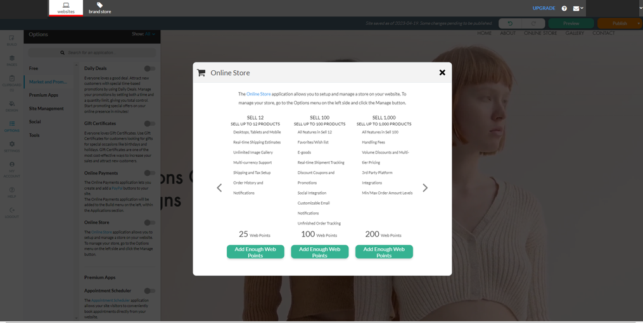

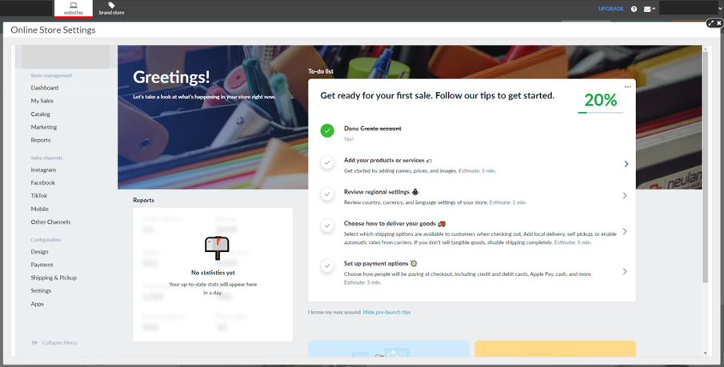The on-boarder will take customers through the necessary steps to get set up.
The first step is to add Products that your customers wish to sell online.

There are basic and advanced options for adding and managing products.
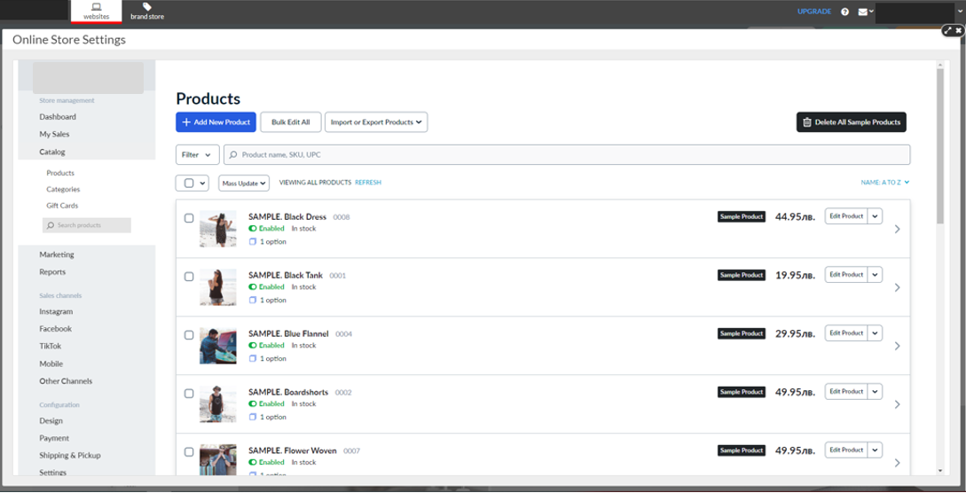

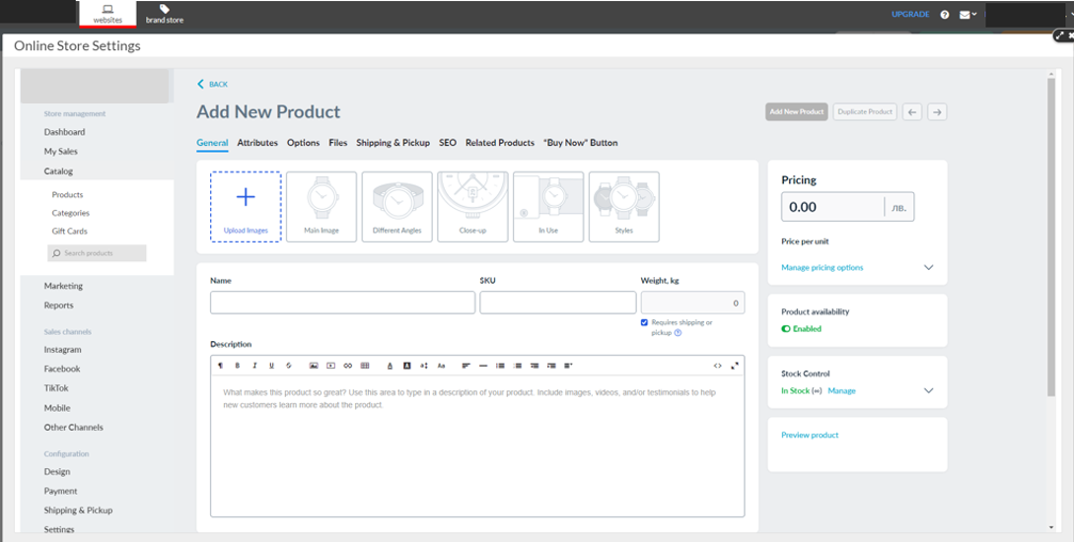The next step is customizing the Online Store for the location. Here is where customers can also set currency and metrics to display on their store.

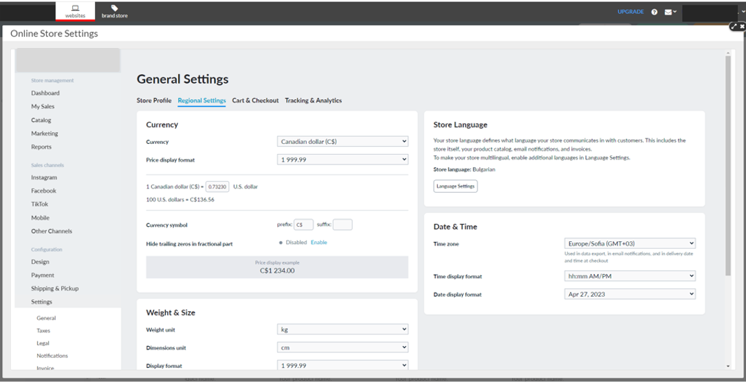
Next, set up shipping options. Define how items are shipped by setting up a carrier, rates and other shipping options.

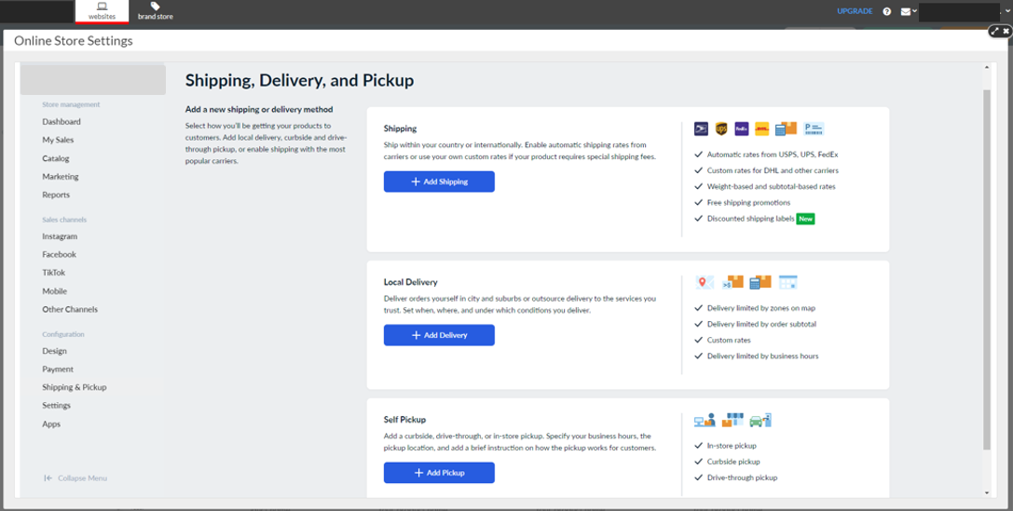For example, choose a local carrier or set flat shipping rates by region.
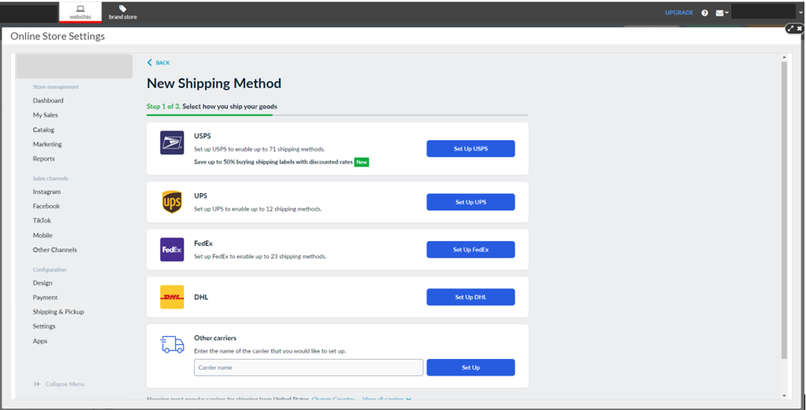

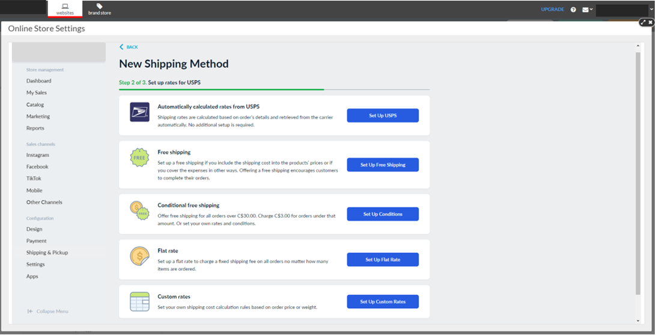
Finally, your customer needs a way to receive payments! They can set up their preferred payment option.
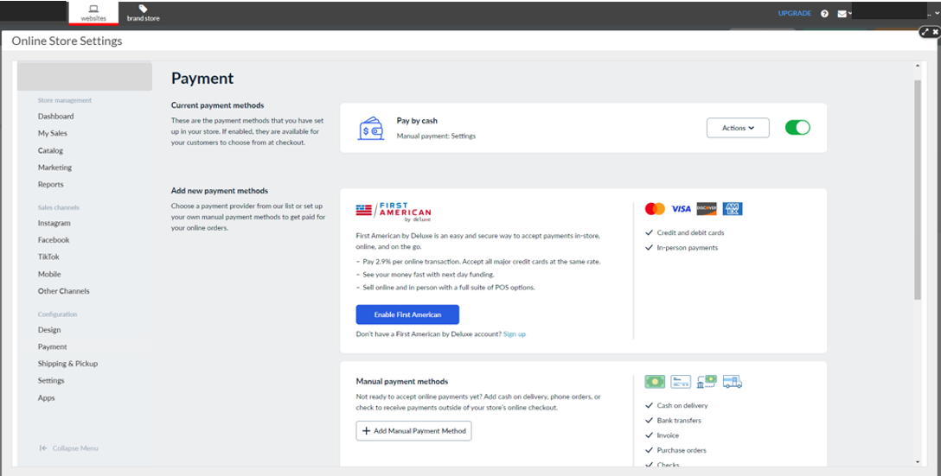

With Sell 100 or higher, customers can unlock more payment options.

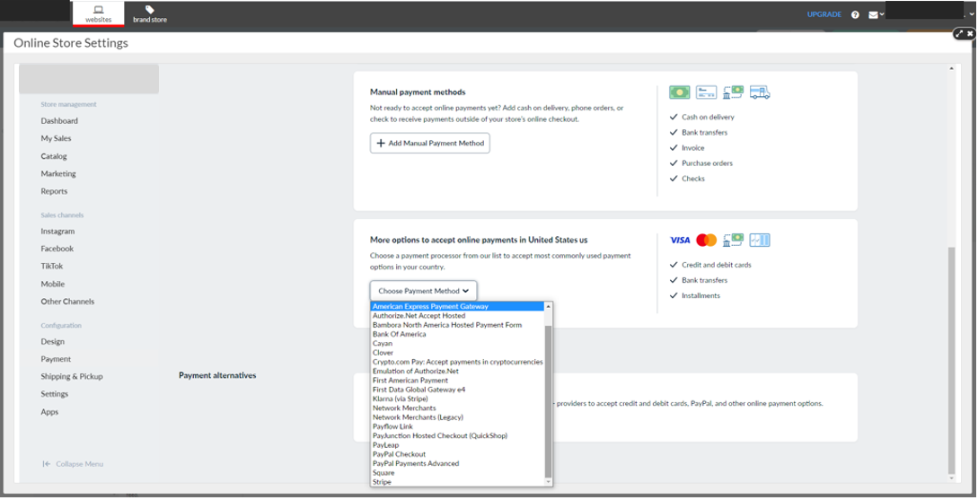
And that’s the simple set up!

Customers can access their sales, catalog and settings in the Online Store panel. Customize settings, including shipping carriers, design of the store, customer and automated notifications, invoicing abandoned carts and more.
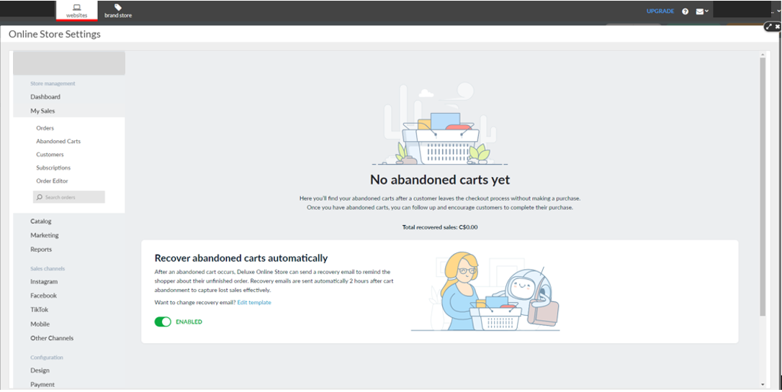

It’s never been easier to set up an online store. Be proud of the finished product:

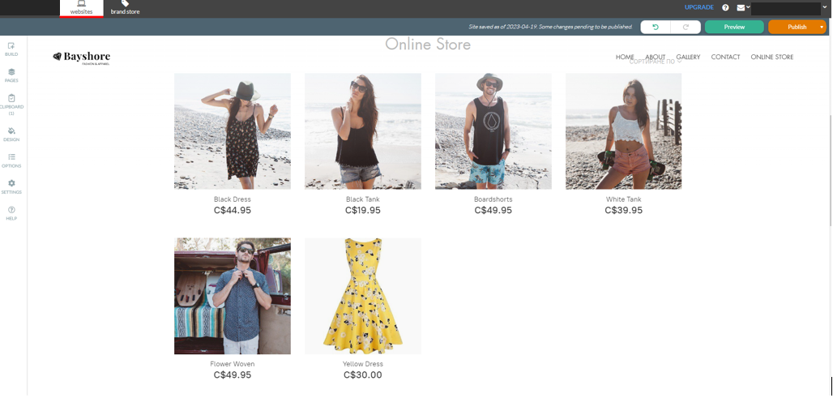

Sales Support

Probing Questions
Are you currently selling products on your website with an Online Store?

- No.
  - With more people going online first to search for products and services, you want to be in a position to convert these shoppers into buyers by offering them the ability to purchase online.
  - Getting started to sell online is simple. Setup your store in minutes. An easy to use on-boarder walks you through adding the product and details and setting basic tax and shipping rates.
- Yes. That’s great.
  - Is it easy to manage?
  - Do you have to use a different tool to manage your storefront versus your website?
  - Do you have proper reporting to manage your product inventory, order history and track payment and shipping status?
  - Are you paying transaction fees with your current solution?

Do you have a Facebook page?

- Yes? Great, Online Store can be integrated right into your Facebook page, as a new tab. It’s quick and easy and you can be selling through your Facebook page today.

- No? Facebook business pages are free, and in just a few minutes you can be selling your products through the most popular social network with Online Presence Builder.

For businesses that provide services to customers:
Have you thought about selling gift certificates?

You don’t have to sell products to sell online. As a business that sell services, you can offer your customers the ability to purchase gift certificates that they can use towards a future purchase. Consider using gift certificates to sell products during high-opportunity occasions, such as Valentine’s Day, birthdays, Halloween or the holidays.

Selling Points
Establish an online presence. Customers are more apt to trust businesses with a professional, up-to-date website. Consumers often use websites to “window shop” and compare products and pricing. Having a professional online store will not only drive online sales for businesses with new customers and new markets but help drive traffic into their physical location as well.

Sell anytime, anywhere, on any device. Online Store adapts to any device, so it looks great across smartphones, tablets and laptops. Today, more customers are using their smartphones than desktops to browse for products and services online, and it’s important that businesses show up.

Increase sales. For a few extra dollars a month, customers can be taking orders from their website 24/7. It’s one of the most cost-effective ways to increase sales and attract new customers.

Build a customer database. Online Store lets customers create profiles for simple purchasing, which can help businesses build a strong base of repeat customers.

Why should customers choose Online Store?
- Online Store is managed directly within Online Presence Builder, so customers can add an Online Store to their existing or new website that is fully branded and responsive, with the same look-and-feel as their website.
- Online Store is optimized for mobile, so the storefront will look great across all devices.
- Online Store’s step-by-step set-up helps automate currency, tax and easily setup shipping methods and rates.
- Unlike other e-commerce solutions, Online Store is managed with the same tool as the website, doesn’t charge any extra transaction fees, and has an incredibly low-cost, high-value return.
- Some other e-commerce solutions require extra steps to making sure the storefront is secure; Online Store is PCI-DSS Level 1 Service Provider Certified, which just means it’s a certified secure solution for customers.

Competitive Information
How does Online Store compare to other e-commerce options in the market?
See Competitive Analysis

Objection Handlers
Selling online is difficult, and I don’t have time to manage it.
The good news is that it has never been easier to start selling online. Anyone can do it and it only takes a few minutes of time to get started.
There’s a quick step-by-step on-boarder that walks you through how to start adding products, how to setup your currency settings and shipping options. Lastly the on-boarder will help you setup your payment options and Payment Processor.
The store will automatically send you an email when an order is placed, and keep you notified when your stock is running low. Online Store does all of the heavy lifting, so you don’t have to.
I already have a website and I don’t want to rebuild it on your system.
Online Presence Builder makes it easy to manage your website and store in one place; and if you have an existing website built on our platform then you can easily add Online Store in a few clicks.
Unlike other ecommerce companies our Online Store offers a great deal of flexibility allowing you to completely integrate with your current Online Presence Builder website.
That means you will not have to rebuild anything!
People would rather shop in store instead of online.
Actually, that’s becoming less and less true. Shoppers are looking for more convenience when purchasing. Attitudes towards purchasing online have changed as more and more shoppers confidently will purchase all kinds of products and services (big or small) online.
Nearly 80% of online buyers shop online at least once a month, with 22% shopping once a week. (Fit Small Business, 2023)
In today’s busy world customers appreciate being able to buy products and services with a few clicks! Your goal should be to making buying your products as easy as possible.
In fact, having an online store will help drive customers through your doors. Consumers are using online stores to “window shop”, to check what you have available and compare features and pricing.
I’d rather invest in social.
With Online Store you can sell your products directly on your Facebook page! This gives your customers a convenient way to buy your products while syncing directly to your central inventory. You can add Online Store to multiple websites, blogs or social media pages, all while managing it in one spot. This makes managing your online presence incredibly simple and strengthens your brand across sites.
I don’t have 100 products to sell, so I only need Sell 12.
The higher level Online Store options have lots of other great features to help you customize your online store.
Sell 12 only supports PayPal, which is a really great way to get started selling online. But you may want to look at using other Payment Gateway providers that offer more customizations and flexibility, such as Stripe.
Upgrading to Sell 100 allows you to customize your email notifications to customers, which is really important for branding and helping your customers remember you.
Sell 100 also lets you enable social sharing from your products pages, so visitors can share and help promote your business. Plus, Online Store also includes other features like discount coupons, Favorites/Wish list, inventory tracking, real-time shipment tracking, and a bit more advanced tracking and reporting to make it easy for you and your customers.
Sell 1000 and Unlimited lets you add volume discounts and has a lot more third-party integration options.

Frequently Asked Questions

General
What is Online Store?
Online Store is a powerful shopping cart/storefront that seamlessly integrates with your existing website. It’s an add-on feature within the easy-to-use cloud-based Online Presence Builder, which allows anyone to build impressive websites that perform on every screen, and helps you get found online.
With Online Store, anyone can add products for sale, set tax and shipping rates, and receive automatic notices when orders are received online.

How can I accept payments; how does selling online work?
Online Store provides various payment methods, starting from accepting credit cards via PayPal to manual order processing. With Sell 100 or above, you will be able to connect your store to major payment processors such as PayPal, Authorize.Net, Stripe, 2checkout and many more.
Online Store doesn't store or transfer the money to you; rather it serves as a go-between in processing payments. Online Store keeps your customers' and orders data and provides you with tools to arrange payment and manage the orders.
‘Payment Methods’ in Online Store is where you set up a way to receive payments. Generally, every online store can support two types of payment methods: online and offline.
Online payment means that the funds are transferred to you (to your payment account)immediately and the customer confirms the payment. Online payments are typically handled via a Payment gateway, an e-commerce application service provider service that authorizes credit card payments. If the credit card information submitted to the payment gateway matches the information on file with the credit card company and the charge is approved, the payment gateway will then transfer the money from your customer’s credit card into your merchant account. The merchant account is basically an online bank account that will temporarily hold your money (you are the merchant) until it is moved into your actual bank account. After a successful sale, money will be transferred into your merchant account and it will sit there for a few days, usually between 2 and 7 days, then, in most cases, it will automatically be transferred into your bank account.

How do I ship my items?
Online Store offers you a flexible mechanism to calculate and charge delivery rates. Choose a local carrier or set flat local, national, and worldwide shipping rates.

Can I charge sales taxes?
Yes, you can setup different tax rates for many regions worldwide as well as within your country.

Is my store secure?
Yes, absolutely. Online Store is PCI-DSS* Level 1 Service Provider Certified. We use highly secured and trusted platforms to store your Online Stores information.
*Payment Card Industry Data Security Standard (PCI DSS) is a worldwide information security standard defined by the Payment Card Industry Security Standards Council. The standard was created to help payment card industry organizations that process card payments prevent credit card fraud through increased controls around data and its exposure to compromise. The standard applies to all organizations that hold, process, or exchange cardholder information from any card branded with the logo of one of the card brands.

How can I upgrade my account?
You can upgrade your account at any time right from the Online Presence Builder ‘Add-ons’ left hand interactions panel. Just follow these easy steps:
- Open Online Presence Builder from your Portal. Please make sure that you're logged in to the account you want to upgrade.
- Go to ‘Add-ons’ within the left-hand interactions panel of Online Presence Builder.
- Select the ‘Online Store’ button and click ‘Learn More’.
- Select the Sell Online plan that you would like to upgrade to. If you do not have the amount of Web Points required, you can purchase more by following the system prompts.
- Once activated, you will be able to access additional features by selecting the Online Store element from ‘Add-ons’ or clicking on your Online Store tab in Online Presence Builder.

What happens if I downgrade Online Store plans?
If you downgrade your account, the functionality included within the higher of the two plans will be gone from your Online Store settings. In case you have more products in your store than are included in the plan you are downgrading to you will be prompted to delete the products exceeding the limit of the plan. Your store will still be available to your customers so you can continue selling.
How can I downgrade my account?
You can downgrade your account at any time right from the Online Presence Builder ‘Add-ons’ left hand interactions panel. Just follow these easy steps:
- Open Online Presence Builder from your Portal. Please make sure that you're logged in to the account you want to downgrade.
- Go to ‘Add-ons’ within the left-hand interactions panel of Online Presence Builder.
- Select the ‘Online Store’ button and click ‘Learn More’.
- Select the Sell Online Plan that you would like to downgrade to, upon selecting this plan the difference in your Web Points will be automatically be adjusted and made accessible to you to purchase additional products.
- From successful downgrade your store plan will automatically change and provide you with the features that are included with your new plan.

Can I cancel my subscription?
You can cancel your subscription by calling into customer service.

Do you charge transaction fees from the sales on my store?
No, we do not charge transaction fees from your sale.
However, the payment gateway you choose to process orders online may charge transaction fees and other service fees. A payment gateway is an e-commerce application service provider that authorizes credit card payments. There are free and affordable options; be sure familiarize yourself with all the important details and potential fees associated with your chosen payment gateway.

Where can I access help information?
You can access help information at any time right from the Online Presence Builder ‘Help Icon’ left hand interactions panel. Just follow these easy steps:
- Open Online Presence Builder from your Portal.
- Go to ‘Help’ within the left-hand interactions panel of Online Presence Builder.
- You now have access to a variety of helpful information on how to manage your Online Store and Online Presence.

How do customers buy my products?
Here are the basic steps associated to making online purchases:
- Customer browses your Online Store catalog, adds an item(s) to the bag, and goes to checkout (opens their bag and clicks 'Checkout' button).
- Customer then inputs a shipping address (if the items are shipped) and picks up a shipping method.
- Customer chooses a preferred payment method and inputs their billing address.
- Completes the order.

Step #4 can be divided into more steps and differs depending on what payment method is chosen.
Online Store doesn't store or transfer the money to you; rather it serves as a go-between in processing payments. Online Store keeps your customers' and orders data and provides you with tools to arrange payments and manage the orders.
‘Payment Methods’ in Online Store is where you set a way to receive payments. Generally, every online store can support two types of payment methods: online and offline.
Online payment means that the funds are transferred to you (to your payment account) immediately. Online payments are typically handled via a Payment gateway, an e-commerce application service providerthat authorizes credit card payments.
Offline payment implies that the money is transferred later since the customer is supposed to arrange the transfer offsite: for ex., go to a nearby bank to transfer the money (that would be bank/wire transfer payment method), or you should give the customer a call to agree on the payment ("Phone order" payment method), or customer will give cash to the courier, etc.

I want to accept credit cards.
The process of receiving money for your sales via an online payment method involves three parties:
- Your Online Store within Online Presence Builder
- Payment gateway: special system, located outside your store but connected to it on programming level, that processes your customers' credit cards (or e.g. PayPal accounts) and charges the card.
- Your merchant account at the payment gateway connected to your bank account.
To put it simply, your store connects to the payment gateway, transmits the order details, the payment gateway processes the customer's credit card and transfers the money to your merchant account. Then you can withdraw the funds to your bank account.

What do I need to start accepting credit cards?

- Open a bank account where you will transfer the money from your purchases.
- Find a payment company/processor from the list in Appendix #1 (PayPal is the simplest to start with).
- Sign up for an account with the chosen company.
- Configure the payment method in your Online Store according to instructions from our knowledgebase.
- Make sure it works properly. A recommended way would be to create a test product at, e.g., $0.01 and try to buy it as a usual customer. If the payment is setup correctly, your order will be recorded under Accepted status in your Online Store panel within Online Presence Builder.
Can Online Store Track Inventory?
Online Store allows tracking inventory on the product level. You can define a quantity for each product separately. Product quantity is automatically reduced when an item has been bought. When the quantity reaches zero, the product is put in “Out of stock” status and can’t be ordered anymore. The Online Store administrator gets notified.

Management & Installation
How do I manage my store?
All store setup and information on your customers and orders are done from the Online Store panel within Online Presence Builder located in the ‘My Add-ons’ left hand interactions panel. If you have not yet added the Online Store you must first do so by going to the ‘Add-Ons’ left hand interactions panel. Once you add Online Store, you will receive access to this panel within My Add-ons, your website will also have an Online Store page automatically setup for you within your site menu.

How do I setup my store?
We have made this as easy as possible for you, after selecting Online Store within My Add-ons upon the first instance we provide you with an easy-to-follow Online Store setup wizard. Just follow these easy steps, to get you started selling online:
- Add Products – get used to adding products for sale by adding a product image, product name and the price of the product.
- Verify Your Location – Country and Currency.
- Set up how your products are delivered – Physical or Digital goods.
- Set up your payment options.
- Click Publish!

The main sections of the Online Store panel include:
- Dashboard: This page is occupied by an installation wizard that will guide you through all necessary setup steps to open an Online Store within Online Presence Builder, and display a sample summary of store activity (latest orders, store ID, total of sales, etc.)
- Sales: This page will display all orders made by your customers in your Online Store.
- Catalog: Here you will load and manage your products and categories.
- Customers: This section will have a list of customers who have created profiles in your store.
- Promotion: Several extra features to extend your selling experience, Coupons, Volume Discounts and third-party Marketplaces.
- System Settings: Configure your payment methods, shipping, taxes, store languages, currency, etc.

Plans & Pricing
What Online Store Plans are available?
Online Store features four plans, each available through the Web Points system:
Sell Online 12 Products – 25 Web Points
Sell Online 100 Products – 100 Web Points
Sell Online 1,000 Products – 200 Web Points
Sell Online Unlimited Products – 400 Web Points
For a listing of production features, please see Appendix 1 of this document

I see the number of product limits that I can sell change by plan, why else should I upgrade other than product limits?
The higher level options have lots of other great features to help you customize your online store.
Sell 12 only supports PayPal, which is a really great way to get started selling online. But you may want to look at using other Payment Gateway providers that offer more customizations and flexibility, such as Stripe.
Upgrading to Sell 100 allows you to customize your email notifications to customers, which is really important for branding and your customers to remember you. Sell 100 also lets you enable social sharing from your products pages, so visitors can share and help promote your business. Plus other features like a discount coupons, Favorites/Wish list, inventory tracking, real-time shipment tracking, and a bit more advanced tracking and reporting.
Sell 1000 and Unlimited lets you add in volume discounts and has a ton more third-party integration options.

Payment Integrations
Do you integrate with QuickBooks or other accounting software?
With our APIs, you can pass data from the sales records in your Online Store to your own accounting software.

What payment gateways are supported in my country?
View the available options in System Settings > Payment. There is also a comprehensive list of available payment gateways supported by Online Store which can be found in Appendix #1 of this document.

Can I sell event tickets within my Online Store?
Absolutely! Online Store can be used to sell just about anything. You can provide a digital ticket customized based on the customer by using an event booking software combined with our Order API. If it is a physical ticket, it can just be shipped to the customer.

Shipping
Can drop-shippers use Online Store?
Yes! We have many customers who use drop shipping services. In fact, Doba, one of the largest US based drop-shipping fulfillment companies recommends their customers to Online Store. Also, merchants can enter their fulfillment service’s email address in System Settings > Mail to receive order notifications automatically. Bonus!

Full Feature List
Plan | Sell 12 | Sell 100 | Sell 1,000 | Sell Unlimited
Web Points Required to Activate | 25 | 100 | 200 | 400
Transaction Fees | None | None | None | None
Product limit | 12 | 100 | 1000 | Unlimited
Categories | Unlimited | Unlimited | Unlimited | Unlimited
Storage | Unlimited | Unlimited | Unlimited | Unlimited
Bandwidth | Unlimited | Unlimited | Unlimited | Unlimited
Shopping Experience
Mobile Adaptive Storefront Widget (desktop, tablet, mobile) | Yes | Yes | Yes | Yes
Favorites/Wish list |  | Yes | Yes | Yes
Single product widgets | Yes | Yes | Yes | Yes
Faceted search and product display filters: by keywords, attributes, price range, category | Yes | Yes | Yes | Yes
Products already in cart are marked in product list, making shopping easier | Yes | Yes | Yes | Yes
Real-time shipping estimates based on customer IP | Yes | Yes | Yes | Yes
Customer can create profile or checkout without creating profile (configurable) | Yes | Yes | Yes | Yes
Address book for customers with profiles | Yes | Yes | Yes | Yes
Media rich category and product descriptions | Yes | Yes | Yes | Yes
Accept the Terms and Conditions before ordering | Yes | Yes | Yes | Yes
Next / Previous product navigation links | Yes | Yes | Yes | Yes
Storefront for old feature phones | Yes | Yes | Yes | Yes
Automatic price adjustment for product options | Yes | Yes | Yes | Yes
Fast content delivery with CDN |  | Yes | Yes | Yes
Catalog Management
Built-in storefront translations | 45 | 45 | 45 | 45
Built-in backend translations | 15 | 15 | 15 | 15
Inventory tracking |  | Yes | Yes | Yes
Product options (Drop-down, Radio Buttons, Text, Date Picker, File, Checkboxes) | Yes | Yes | Yes | Yes
Stock control for options & product combinations |  |  | Yes | Yes
E-goods |  | Yes | Yes | Yes
E-goods download protection |  | Yes | Yes | Yes
Customers can attach files to orders |  | Yes | Yes | Yes
Image gallery | Unlimited | Unlimited | Unlimited | Unlimited
WYSIWYG editor for HTML product descriptions | Yes | Yes | Yes | Yes
Automatic thumbnail generation with image sharpening | Yes | Yes | Yes | Yes
Product can be in more than one category | Yes | Yes | Yes | Yes
Product types and attributes | Yes | Yes | Yes | Yes
Multi-currency support | Yes | Yes | Yes | Yes
Shipping and Tax
Delivery zones | Unlimited | Unlimited | Unlimited | Unlimited
Shipping configuration wizard | Yes | Yes | Yes | Yes
Flexibly configurable Shipping/Tax zones, rates and rules | Yes | Yes | Yes | Yes
Real-time shipping quotes for UPS, USPS, FedEx, Canada Post, EMS Russian Post, Correios and Australia Post | Yes | Yes | Yes | Yes
Use real-time quotes without setting account with carrier | Yes | Yes | Yes | Yes
Real-time shipment tracking |  | Yes | Yes | Yes
Handling fees |  |  | Yes | Yes
Promotions
Discount coupons |  | Yes | Yes | Yes
Volume discounts and multi-tier prices |  |  | Yes | Yes
Sale and promotional price | Yes | Yes | Yes | Yes
Discounts for customer groups |  |  | Yes | Yes
Facebook Like buttons | Yes | Yes | Yes | Yes
Facebook comments |  | Yes | Yes | Yes
Share purchase on Facebook, Twitter |  | Yes | Yes | Yes
Share product on Facebook, Pinterest, Twitter, Google+, Tumblr |  | Yes | Yes | Yes
Ask friends |  | Yes | Yes | Yes
Basic affiliate features |  | Yes | Yes | Yes
Integrations
Free Facebook integration app | Yes | Yes | Yes | Yes
Remarketing with Google Analytics |  | Yes | Yes | Yes
Google Shopping Feeds |  |  | Yes | Yes
ShopZilla (+Bizrate) Feeds |  |  | Yes | Yes
eBay Shopping Feeds (Shopping.com) |  |  | Yes | Yes
Amazon Products Ads |  |  | Yes | Yes
PriceGrabber Feeds |  |  | Yes | Yes
Yahoo.com Shopping Feeds |  |  | Yes | Yes
Nextag Comparison Platform Feeds |  |  | Yes | Yes
Yandex.Market Feed |  |  | Yes | Yes
Orders
Customizable e-mail notifications |  | Yes | Yes | Yes
Order history for customers and administrator | Yes | Yes | Yes | Yes
Order email notifications to multiple recipients | Yes | Yes | Yes | Yes
Track payment and shipping status | Yes | Yes | Yes | Yes
Customer IP in order details |  | Yes | Yes | Yes
Warning if IP is different from billing country |  | Yes | Yes | Yes
View unfinished orders |  | Yes | Yes | Yes
Invoice printing | Yes | Yes | Yes | Yes
Bulk invoice printing |  | Yes | Yes | Yes
Edit Invoice |  |  | Yes | Yes
Order comments field | Yes | Yes | Yes | Yes
Configurable min/max order amount limits |  |  | Yes | Yes
Low stock notification | Yes | Yes | Yes | Yes
Set next order number |  | Yes | Yes | Yes
Data Management
CSV export for order, product and customer data |  | Yes | Yes | Yes
CSV import for product data | Yes | Yes | Yes | Yes
Configurable measurement units, date/time formats and currency symbol. | Yes | Yes | Yes | Yes
SEO
Native AJAX indexing |  | Yes | Yes | Yes
Tracking and Reporting
Tracking and e-commerce reporting with Google Analytics | Yes | Yes | Yes | Yes
Custom tracking code on “Thank you for your order” page |  | Yes | Yes | Yes

<< DOCUMENT END >>

